Revolutionizing Talent Acquisition: How PeakU's AI-Powered Platform is Disrupting the HR Industry



The COVID-19 pandemic has accelerated the shift towards remote work, causing companies to expand their search for top talent globally. Traditional applicant tracking systems (ATS) are no longer sufficient to meet this need, and this is where PeakU comes in.

The platform founded by Santiago González and Juan Pablo Isaza in 2020, is shaking up the traditional recruiting industry with its all-in-one platform that combines traditional applicant tracking systems (ATS) with its own technical, cognitive, and personality tests. In addition, the platform includes tools for managing specialized talent and the ability to pay international talent in any country in the world.

PeakU's secret weapon is a machine learning algorithm that actually works. According to Santiago, "Recruiting used to be limited to local talent, with companies primarily searching for candidates within their own country. Remote work was not a common option for most companies, particularly larger corporations. However, due to the ongoing pandemic, companies are now expanding their search globally in order to find the best talent. PeakU's platform and technology facilitate this process, which is why we have seen significant growth in their usage.."

The timing of the startup’s launch couldn't have been better. With the outbreak of the COVID-19 pandemic and the resulting shift towards remote work, companies are now more reliant than ever on technology to help them find and manage specialized talent. This has led to a huge increase in demand for recruiting solutions like PeakU, which is designed specifically for the new reality of global, remote work.

The company's growth rate is not just a temporary trend, but a sign of the future of the HR industry. According to a report by MarketsandMarkets, the global AI in HR market size is expected to grow from $1.2 billion in 2019 to $9.5 billion by 2024, at a CAGR of 44.8% during the forecast period. This growth is driven by the increasing adoption of AI-powered tools in recruitment, talent management, and

The platform is at the forefront of this trend, and it holds an unfair advantage as the only one with access to information on abilities and CVs. Its cutting-edge AI technology can automate many of the tedious and time-consuming tasks associated with recruiting and managing talent, allowing humans to focus their efforts on meeting people who have already been filtered for interviews and more complex assessments. This not only saves companies time and money but also enables them to find the best candidates for the job, regardless of their location in the world.

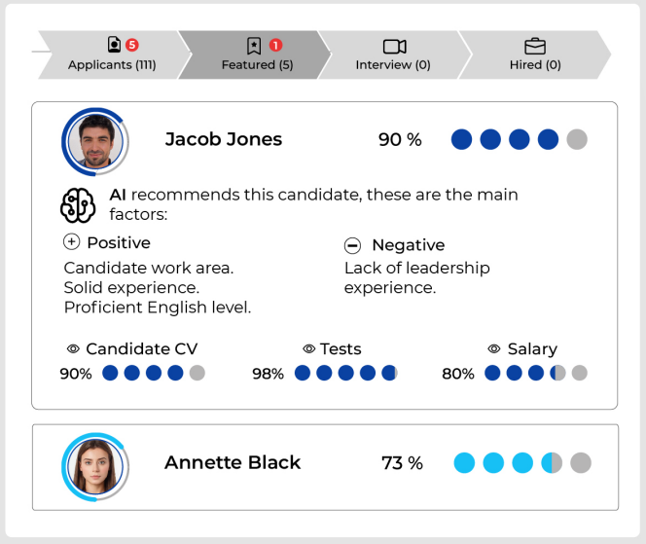

In conclusion, this platform is disrupting the HR industry by revolutionizing the way companies find and manage specialized talent. With the global AI in HR market expected to reach $9.5 billion by 2024, PeakU's growth is a sign of the future of the industry.